Software Requirements Specification

for

COVID Medicare App

**Version 1.2 approved**

**Prepared by Vanshika Mediratta & Udit Thakur**

**Manipal University Jaipur**

**22/11/2020**

Table of Contents

**1. Introduction** 3

**1.1** **Purpose** 3

**1.2**  **Document Conventions** 3

**1.3** **Intended Audience and Reading Suggestions** 3

**1.4** **Product Scope** 4

**1.5** **References** 4

**2.** **Overall Description** 5

**2.1** **Product Perspective** 5

**2.2** **Product Functions** 5

**2.3** **User Classes and Characteristics** 6

**2.4** **Operating Environment** 6

**2.5**  **Design and Implementation Constraints** 6

**2.6** **User Documentation** 7

**2.7** **Assumptions and Dependencies** 7

**3.** **External Interface Requirements** 7

**3.1** **User Interfaces** 7

**3.2** **Hardware Interfaces** 8

**3.3** **Software Interfaces** 8

**3.4** **Communications Interfaces** 8

**4.** **System Features** 8

**4.1** **LogIn/ Logout/ Register** 8

**4.2** **Chatbot** 9

**4.3** **Mask Detection** 9

**4.4** **Social Distancing Monitor** 10

**4.5** **Blogs** 10

**5.** **Other Nonfunctional Requirements** 11

**5.1** **Performance Requirements** 11

**5.2** **Safety Requirements** 11

**5.3** **Security Requirements** 11

**5.4** **Software Quality Attributes** 11

**6.** **Other Requirements** 12

**Appendix A**: Glossary 12

**Appendix B**: Analysis Models 13

**Appendix C**: COCOMO Models & Function Point 16

**Appendix D**: UML Diagrams 17

**Appendix E**: Application Screenshots 23

**Revision History**

|  |  |  |  |
| --- | --- | --- | --- |
| **Name** | **Date** | **Reason For Changes** | **Version** |
| Surveys & Predictions | 01/11/2020 | Discarding Surveys and Covid Predictions | 1.1 |
| Uml Diagrams | 22/11/2020 | Added UML Diagrams | 1.2 |

# **1. Introduction**

## **1.1** **Purpose**

The COVID - 19 pandemic has created havoc all across the globe with very limited knowledge regarding it. Our application hopes to eradicate that by giving features which helps solve the issues of millions of people. The software undergoes testing and updates regularly to give the best possible features in an attempt to make the lives of the people better.

## **1.2 Document Conventions**

This document uses bold words to address features or headings of the applications. Underlined sentences colored in blue are for hyperlinks to the online documentations or source.

## **1.3** **Intended Audience and Reading Suggestions**

The document is **intended** for machine learning engineers, domain expert, developer and project manager. Before **reading** this document it is highly **recommended** to **read** the **OpenCv** documentation to get an overview of the product. This project is useful for machine learning practitioners, people in the field of Science and general audience.

## **1.4** **Product Scope**

The purpose of our software “Covid Medicare” is to help the general population deal with the COVID - 19 pandemic. The main concerns as seen from the public is :   
1. Lack of information  
2. Contact tracing  
3. Social distancing  
4. Fear of being COVID positive.  
Our software aims to address these issues to the best of our capabilities including features like mask detection, chatbot and reading blogs, surveys and predictions generated on the basis of the responses. We also have a feature which aims to generate an alert whenever the standard social distancing parameter is not being followed alerting the user as well as the admin. Blogs written by certified doctors ensure the public of the current situation and precautions to be taken. All this data is also provided to the admin who monitors the activities and carries out processes for contact tracing.

The benefits of this application is endless and our goal is to make it much more accessible and user friendly while respecting the user’s privacy and helping the nation deal with the pandemic.

## **1.5** **References**

* **GUI :** Kivy is an open source software library for the rapid development of applications equipped with novel user interfaces, such as multi-touch apps.

**Kivy Documentation:** [**Welcome to Kivy — Kivy 1.11.1 documentation**](https://kivy.org/doc/stable/)

* **Database Plugin :** MySQL provides standards-based drivers for JDBC, ODBC, and .Net enabling developers to build database applications in their language of choice. In addition, a native C library allows developers to embed MySQL directly into their applications.

**MySQL Documentation:** [**MySQL Documentation**](https://dev.mysql.com/doc/)

* **Computer Vision :** OpenCV is a library of programming functions mainly aimed at real-time computer vision**.**

**OpenCv Documentation:** [**OpenCV modules**](https://docs.opencv.org/4.2.0/)

* **Chat Bot :** NLTK is a leading platform for building Python programs to work with human language data. It provides easy-to-use interfaces to [over 50 corpora and lexical resources](http://nltk.org/nltk_data/) such as WordNet, along with a suite of text processing libraries for classification, tokenization, stemming, tagging, parsing, and semantic reasoning, wrappers for industrial-strength NLP libraries, and an active [discussion forum](http://groups.google.com/group/nltk-users).

**NLTK Documentation:** [**Natural Language Toolkit — NLTK 3.5 documentation**](https://www.nltk.org/)

* **Deep Learning :** TensorFlow is a free and open-source software library for dataflow and differentiable programming across a range of tasks. It is a symbolic math library, and is also used for machine learning applications such as neural networks.

**Tensorflow Documentation:** [**All symbols in TensorFlow 2**](https://www.tensorflow.org/api_docs/python/tf/all_symbols)

* **Machine Learning :** Scikit-learn is a free software machine learning library for the Python programming language. It features various classification, regression and clustering algorithms including support vector machines, random forests, gradient boosting, k-means and DBSCAN, and is designed to interoperate with the Python numerical and scientific libraries NumPy and SciPy.

**Scikit Documentation:** [**User guide: contents — scikit-learn 0.23.2 documentation**](https://scikit-learn.org/stable/user_guide.html)

# **2.** **Overall Description**

## **2.1** **Product Perspective**

Medicare app will provide an easy to use interactive gui which will work on the real-time / real-world data driving the power of AI and expose it to the user. The application will be cross platform meaning that it will work both on windows and android devices. At last the product is supposed to be an open source, under the GNU general Public License.

## **2.2** **Product Functions**

The product performs the following tasks and features:

**1.** **Chatbot -** This feature was included to help those with limited knowledge about the pandemic to be better informed. If there are any queries, the chatbot will answer them based on the responses which are apt for the situation. An example could be : “What precautions should I take during the pandemic?”. The response provided would be “As per the guidelines by the government and WHO, a person should wear a mask at all times. Sanitize their hands and maintain at least 6 ft distance with others in public.” All these responses would be regularly updated and new questions would be added based on the user’s request.

**2. Mask Detection -** The purpose of this feature is to check if a person is wearing a mask properly or not. This could be very helpful in shops and public places as the user would immediately be identified and notified.

**3. Social Distancing monitor -** The standard protocol provided regarding the distance between people in this pandemic is 6ft. This feature generates an alert if a person is not following this rule and the same information is provided to the admin. The details of those users who violate this in a continuous manner would be provided to the admin and further action would be taken. This could also be very helpful in public places and would contribute towards contact tracing.

**4. Blogs -** Lack of knowledge regarding this disease creates a lot of confusion and havoc in the general public. To avoid this, we will have certified doctors publish blogs with their view points providing all the information in one platform.

## **2.3** **User Classes and Characteristics**

**Open Source Contributors**: People with good knowledge of programming language projects, in order to understand and be able to extend the project's source code. Anyone who wants to help the FOSS community. The whole project is based on the conception of Free and Open Source Software, so all people are welcome to contribute any way they can/like.

**IT Staff**: IT staff will be the primary maintainers of the application and may have to perform some administrative functions relating to the email alerts and database. The IT Staff will have a technical background and domain knowledge about DBMS.

**Medical Officers**: Professional doctors and practitioners will be responsible for providing all the medical related information and help on the blogs feature of the application. They will also provide insights on the precautions and measures to take during the pandemic.

## **2.4** **Operating Environment**

Medicare app should run on Windows Operating Systems: Windows 7/8/10 and Android devices running on android version: 4.0 +

## **2.5 Design and Implementation Constraints**

Users must have their correct usernames and passwords to enter into their online accounts and do the actions.

Users may access from any computer having windows operating system or android devices with android ver. 4.0+ that have internet browsing capabilities and an internet connection.

The information of all the users, logs and actions must be stored in a database that is accessible by the application

MySql server will be used as SQL engine and database.

## **2.6** **User Documentation**

A separate softcopy of the user manual for each user role would be available with this software which will document how the software should be maintained. Additionally a tutorial shall be provided for the users describing the major use cases for each role.

## **2.7** **Assumptions and Dependencies**

It is to be assumed that all the data used for making predictions comes under GNU license. Everyone that does or is going to develop or use the Medicare App, should agree and fully accept the terms of this kind of license.

**GNU** : [**The GNU Operating System and the Free Software Movement**](https://www.gnu.org/)

# **3.** **External Interface Requirements**

## **3.1** **User Interfaces**

This application is developed for people of all ages and is available only in English language. The user is expected to know how to function with Windows 7/8/10 and android.

**Login Interface**: In this interface, there will be a button register. If a user has not registered to the application, she/he will use the register button to register.

**Register Interface:** In this interface users register to the system by giving information of themselves in a provided text field. There will be a button register. After user filled the required fields with his/her related information (username, password, gender etc.), click to the register button and be able to login the application.

**Chatbot Interface:** In this interface users will get a chance to interact with an AI driven bot who will answer the queries posted by the users themselves.

**Webcam Interface:** This will be used for both mask detection and social distancing monitoring predicting and generating alerts on the screen for the same.

**Blogs Interface:** In this interface users can read the blogs posted by certified medical doctors.

## **3.2** **Hardware Interfaces**

This application works on Android mobile devices and Windows OS. No other hardware is required.

## **3.3** **Software Interfaces**

Since this application is a mobile application, it will only need an Android version 4.0 or higher in order to perform.

## **3.4** **Communications Interfaces**

This device needs a stable internet connection at all times. The permissions that the user has to provide is : access to webcam (optional) and access to geolocation. Email alerts will be generated frequently when the user uses these services.

# **4.** **System Features**

## **4.1** **LogIn/ Logout/ Register**

4.1.1 Description and Priority

This function has a **HIGH** priority as without this, the user will not have access to the other functions. Failure to do so would result in the application being useless.

4.1.2 Stimulus/Response Sequences

Users would be initially asked to register for an account by filling in details including name, phone number, location and a valid email id. In case the user wants to register as a doctor, he/she would be asked to submit documentations so that the admin can verify they are doctors. They can then submit a password and officially register for the application.  
Users would be asked to provide a valid email id and provide a password to log in to the application. If the user forgets the password, they can click on “forgot password” which would send an email to their registered email id where they can update the password.  
Logging out is optional but if done, the user would log out from the application and would have to enter the details again when they next login.

4.1.3 Functional Requirements

* Name, username, email, location and password needs to be entered.
* Email has to be unique and can only be registered once.

## **4.2** **Chatbot**

4.2.1 Description and Priority

This feature is used to help the users to clear their doubts about the pandemic by asking the bot which would be continuously updated with better and more recent responses. The question bank for the bot would also be as diverse as possible. All the answers would be verified by medical practitioners. This feature has a **MEDIUM** priority as its functionality depends upon the user.

4.2.2 Stimulus/Response Sequences

The user would click on the chatbot icon where a message would be prompted by the bot. The user can then ask a question from the text bar at the bottom of the screen. For example, “How many cases are there currently in India?”. The chatbot, based on the data it has would provide an answer like “Currently there are 5.9 million cases in India.” And the conversation could continue in a similar manner.

4.2.3 Functional Requirements

* Queries need to be COVID related.
* Queries have to be valid.

## **4.3** **Mask Detection**

4.3.1 Description and Priority

The purpose of this feature is to check if a person is wearing a mask properly or not. This feature has **MEDIUM** priority as in a public place, it could be easily determined who wasn’t wearing it properly. An email would be generated for the user and this would help in contact tracing.

4.3.2 Stimulus/Response Sequences

The user would have to click on a widget which would open to a new window asking for camera permissions. If accepted, the user would be able to see their image on the phone with a green light as a border if the mask is worn properly or a red light if not. If this persists, an email would be generated informing the user of the same. An option to exit would be provided to exit this feature.

4.3.3 Functional Requirements

* Permission to access the webcam must be provided.
* This functionality will make predictions based on your input so position yourself accordingly.
* Camera should preferably be a HD front or back camera

## **4.4** **Social Distancing Monitor**

4.4.1 Description and Priority

This feature is used to monitor if a person is maintaining a 6ft distance with other people in public places or not. This gives it a **MEDIUM** priority. If 6ft is not maintained, an email alert would be generated informing the user of the same. This is extremely useful in public places as it would help in contact tracing.

4.4.2 Stimulus/Response Sequences

The user would have to click on the widget which would open a new window asking for camera permissions. If granted, the user would use the back camera to navigate his/her way which would monitor the geolocation as well as the distance between people. The user can exit this feature by clicking on the exit icon.

4.4.3 Functional Requirements

* Permission to access the webcam must be given.

## **4.5** **Blogs**

4.5.1 Description and Priority

There is a lot of confusion in the general public regarding this disease as it’s fairly new. To remove this lack of knowledge, the “Blog” feature allows certified doctors to publish medical blogs regarding this disease. This would keep the user updated about the same and would help in providing general knowledge. This feature has **MEDIUM** priority.

4.5.2 Stimulus/Response Sequences

The user would have to click on the blog widget present on the home screen to open a window containing a list of blogs. They could go through them and save them as they like, They can also exit the feature by clicking on the exit icon present on the screen.

4.5.3 Functional Requirements

* All data present in the blog must be valid.
* The maximum word length is 250 words and cannot exceed that.

# **5.** **Other Nonfunctional Requirements**

## **5.1** **Performance Requirements**

The system must be interactive and the delays involved must be less. So in every action-response of the system, there are no immediate delays. In case of opening Chatbot, or popping error messages and saving the settings or sessions there is delay much below 2 seconds, In case of opening webcam, showing predictions and validation there are no delays and the operation is performed in less than 2 seconds for opening , computing, posting > 95% of the video frames. Also when connecting to the server the delay is based on editing on the distance of the 2 systems and the configuration between them so there is high probability that there will be or not a successful connection in less than 20 seconds for sake of good communication.

## **5.2** **Safety Requirements**

The application is completely safe to use and will not trigger any kind of anti-virus or firewall exception. Medicare App is an open-source project, so anyone who has doubts is able to check the source code.

## **5.3** **Security Requirements**

The main security concern is for users' accounts hence proper login mechanism should be used to avoid hacking. The id registration is a way to spam check for increasing the security. For the email alerts generated, all the data is sent over an encryption service to the administrator. Hence, security is provided from unwanted use of recognition software.

## **5.4** **Software Quality Attributes**

As the system provides the right tools for discussion, contact tracing and object detection it must be made sure that the system is reliable in its operations and for securing the sensitive details. The application is easy to handle and navigates in the most expected way with no delays. In that case the system program reacts accordingly and transverses quickly between its states.

# **6.** **Other Requirements**

Any miscellaneous requirements that do not fit into the above subsections.

6.1 AI driven Chatbot

None.

6.2 Mask detection & Social Distancing Monitor

None.

6.3 Administrator and User Databases

The connector for the required databases should be supported for the previously mentioned compatible devices.

6.4 Survey & Predictions

None.

6.5 Blogs

The author of the blogs published i.e. professional medical officers should agree to all the terms and conditions from an authorised organization of the same domain.

# **Appendix A**: Glossary

* A Software requirements specification (SRS), a requirements specification for a software system, is a complete description of the behavior of a system to be developed and may include a set of use cases that describe interactions the users will have with the software.

**Source**: [Software requirements specification](http://en.wikipedia.org/wiki/Software_requirements_specification)

* The GNU General Public License (GNU GPL or GPL) is the most widely used free software license, which guarantees end users (individuals, organizations, companies) the freedoms to use, study, share (copy), and modify the software.

**Source**: [GNU General Public License](https://en.wikipedia.org/wiki/GNU_General_Public_License)

* Free and open-source software (FOSS) is computer software that can be classified as both free software and open source software. That is, anyone is freely licensed to use, copy, study, and change the software in any way, and the source code P a g e | 30 is openly shared so that people are encouraged to voluntarily improve the design of the software.

**Source**: [Free and open-source software](https://en.wikipedia.org/wiki/Free_and_open-source_software)

# **Appendix B**: Analysis Models

**DFD: Level 0**

A basic overview of the whole system or process being analyzed or modeled. It’s designed to be an at-a-glance view.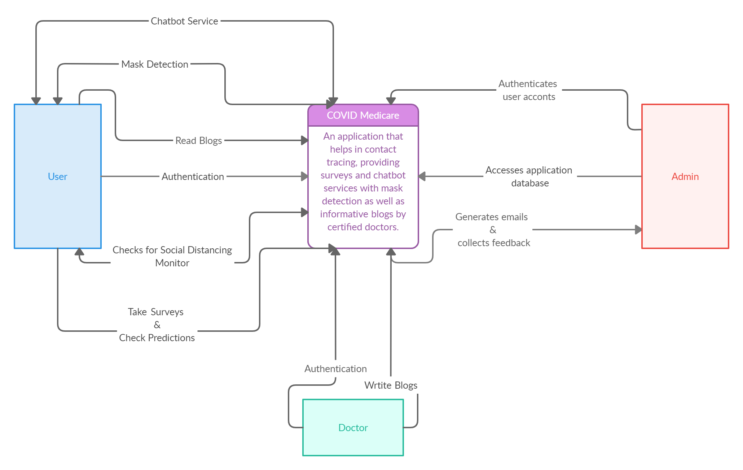

**DFD: Level 1**

This level provides a more detailed breakout of pieces of the Context Level Diagram. The main functions are highlighted and carried out by the system, as you break down the high-level process of the Context Diagram into its sub processes.

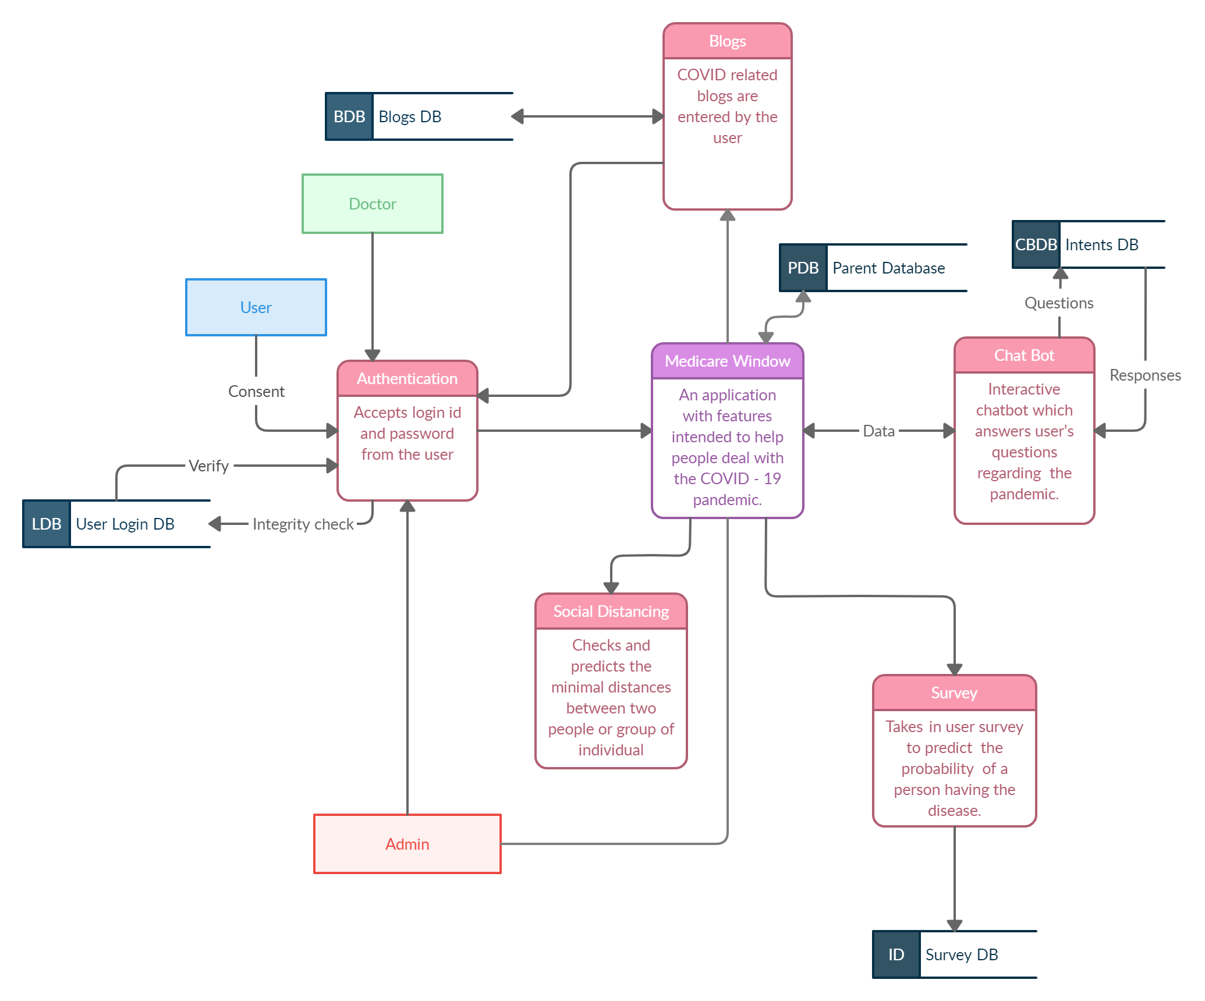

**DFD: Level 2**

This level then goes one step deeper into parts of Level 1. It may require more text to reach the necessary level of detail about the system’s functioning.

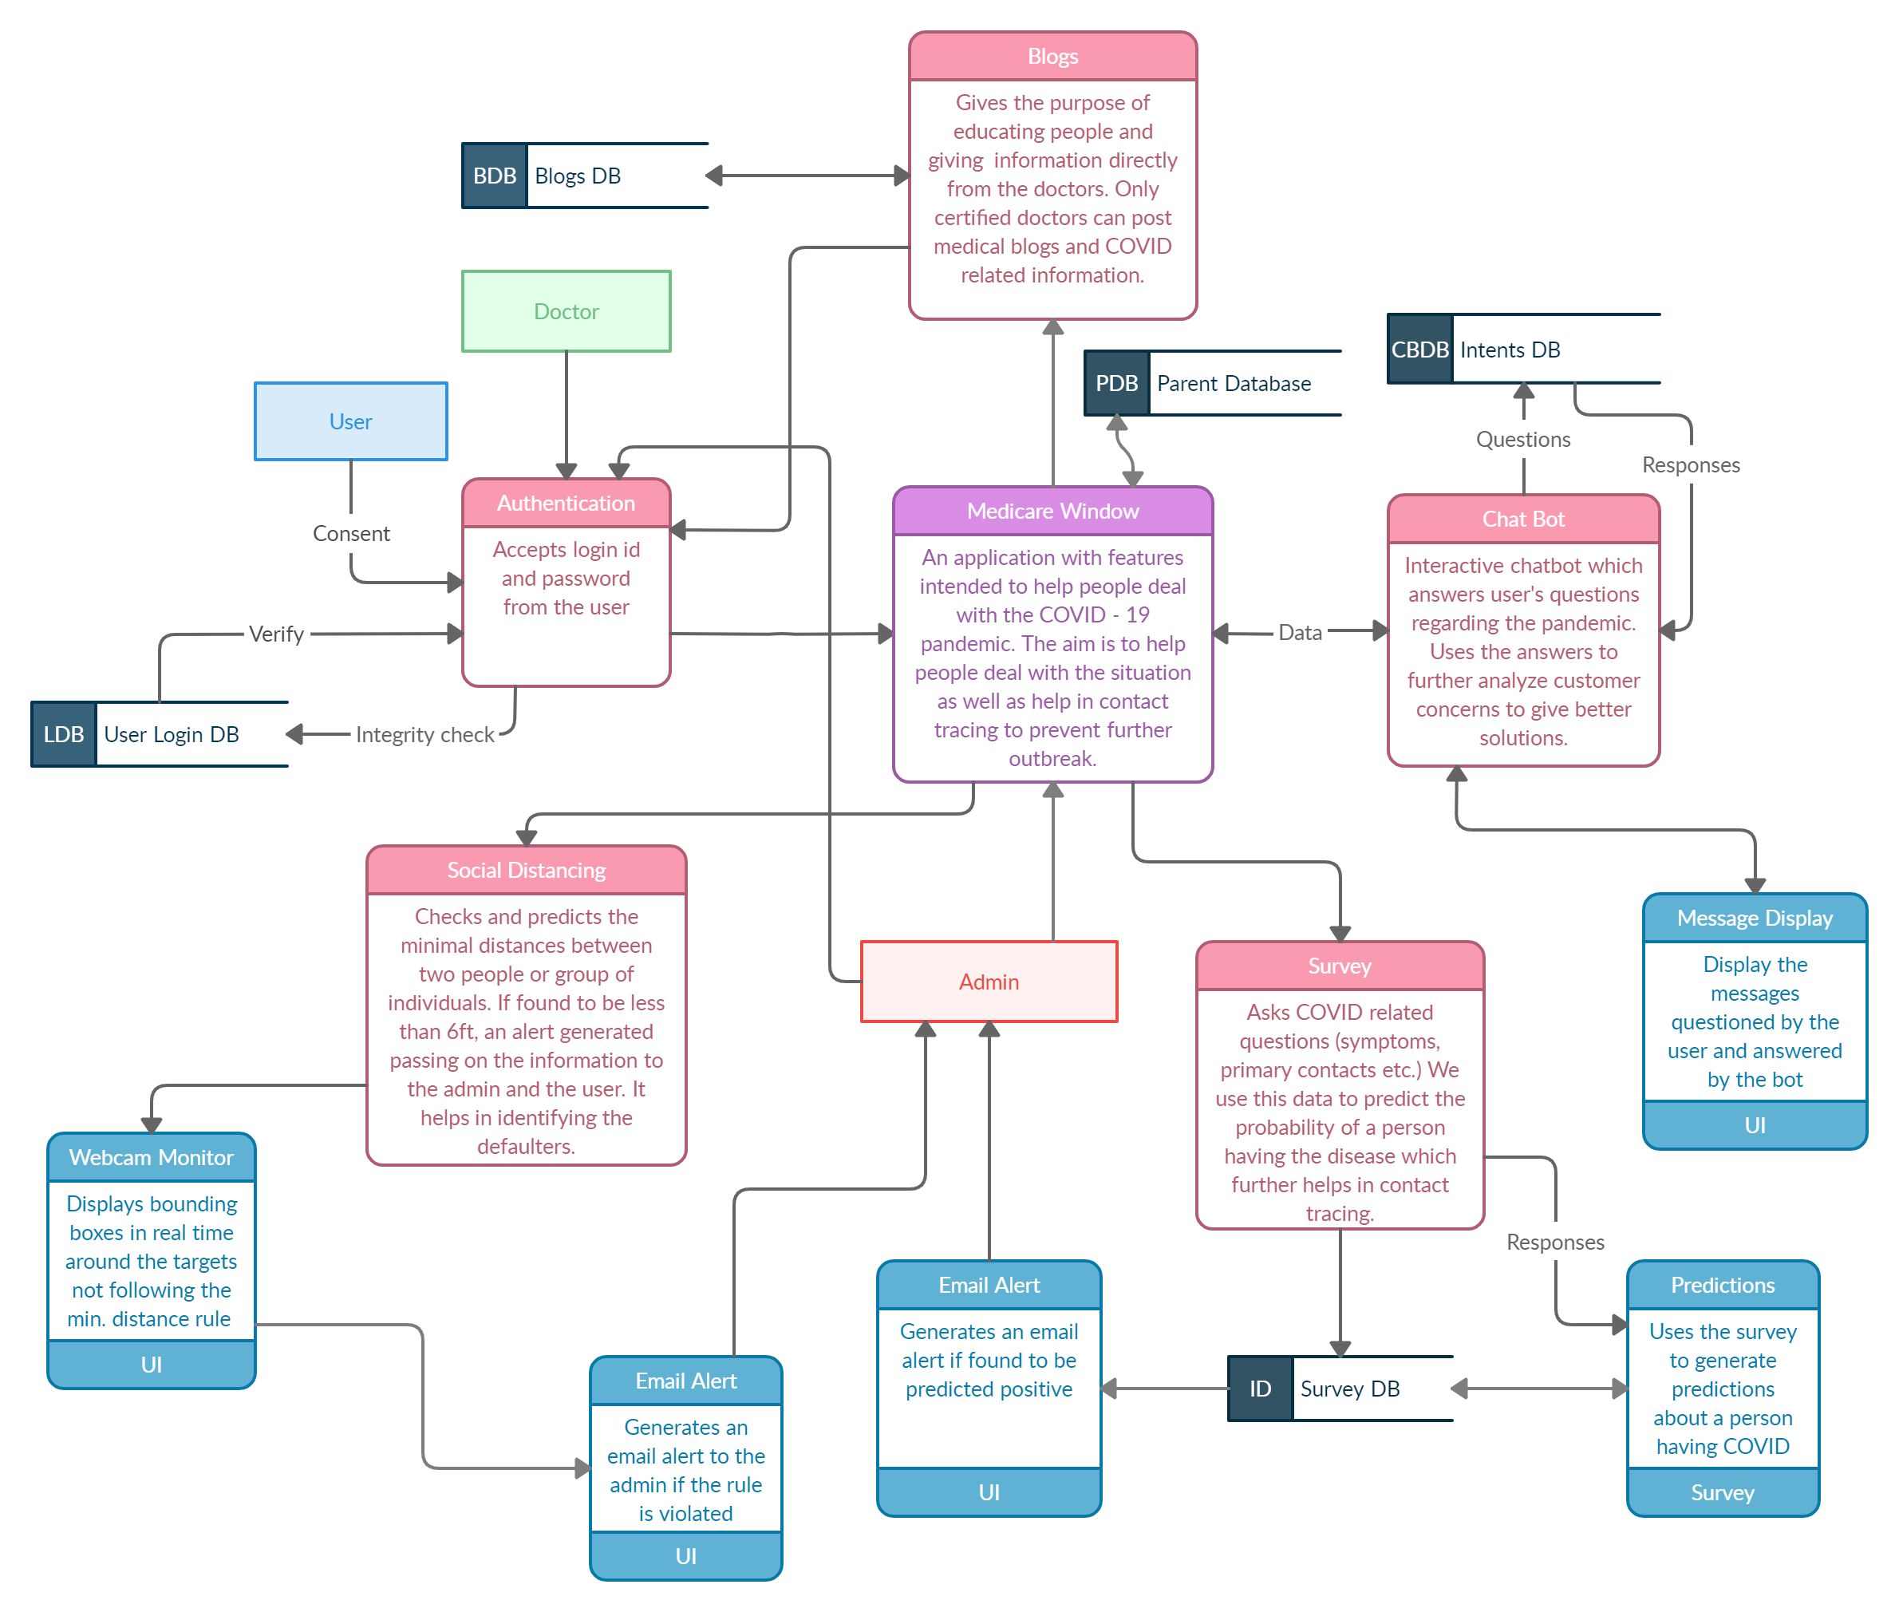

# **Appendix C**: COCOMO Models & Function Point

**COCOMO 1**

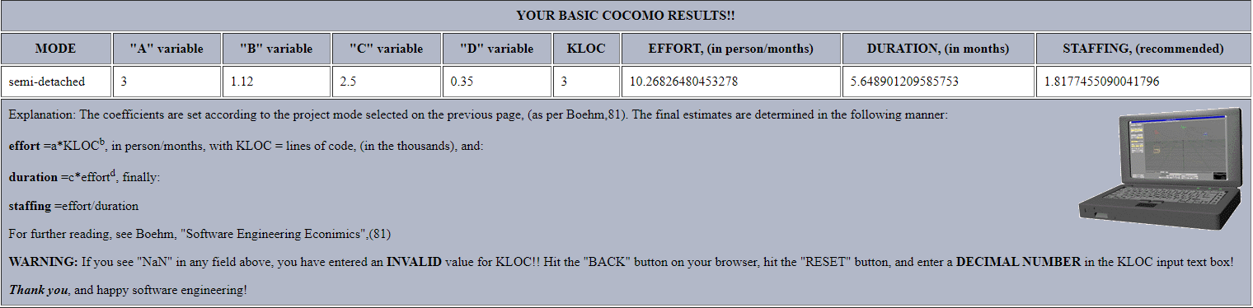

**COCOMO 2**: **Function Point**

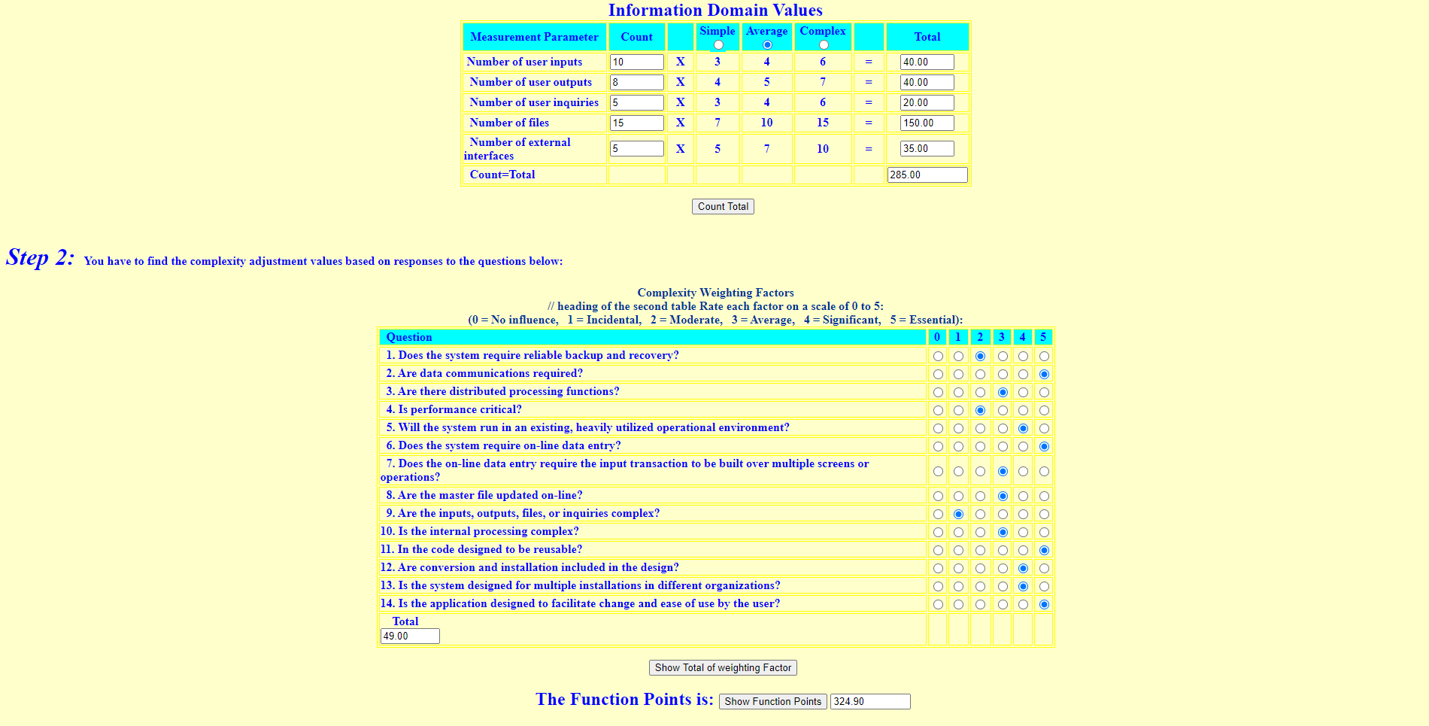

# 

# **Appendix D**: UML Diagrams

1. UML Class Diagram

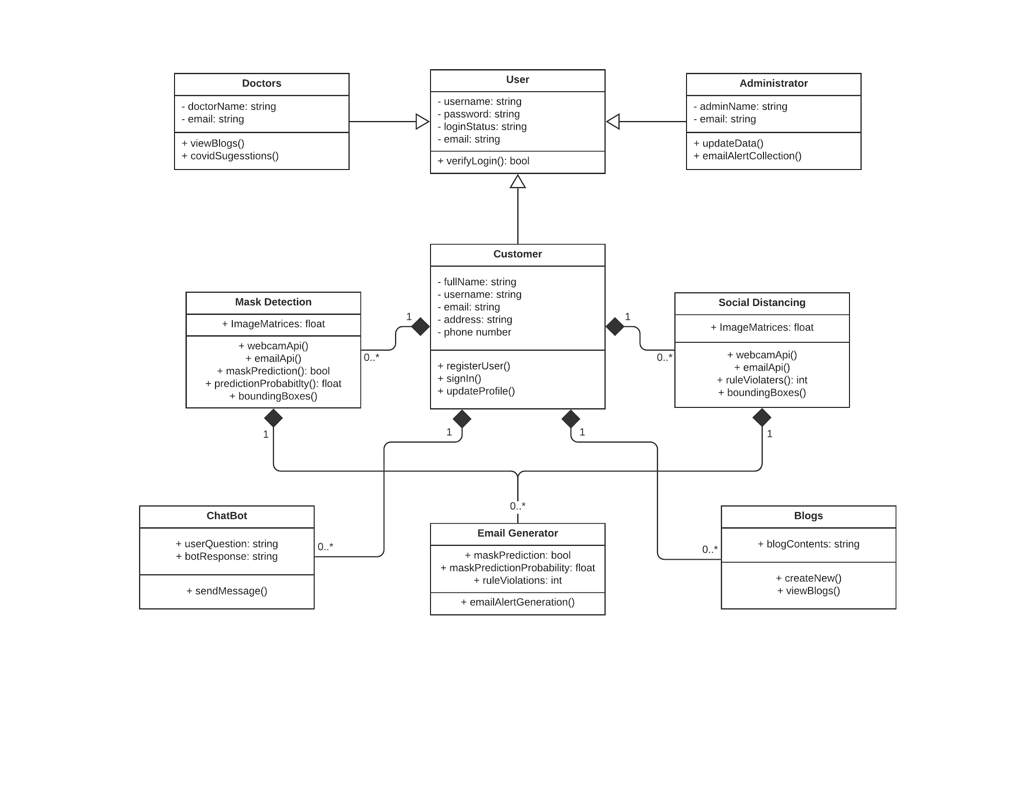

1. UML Object Diagram

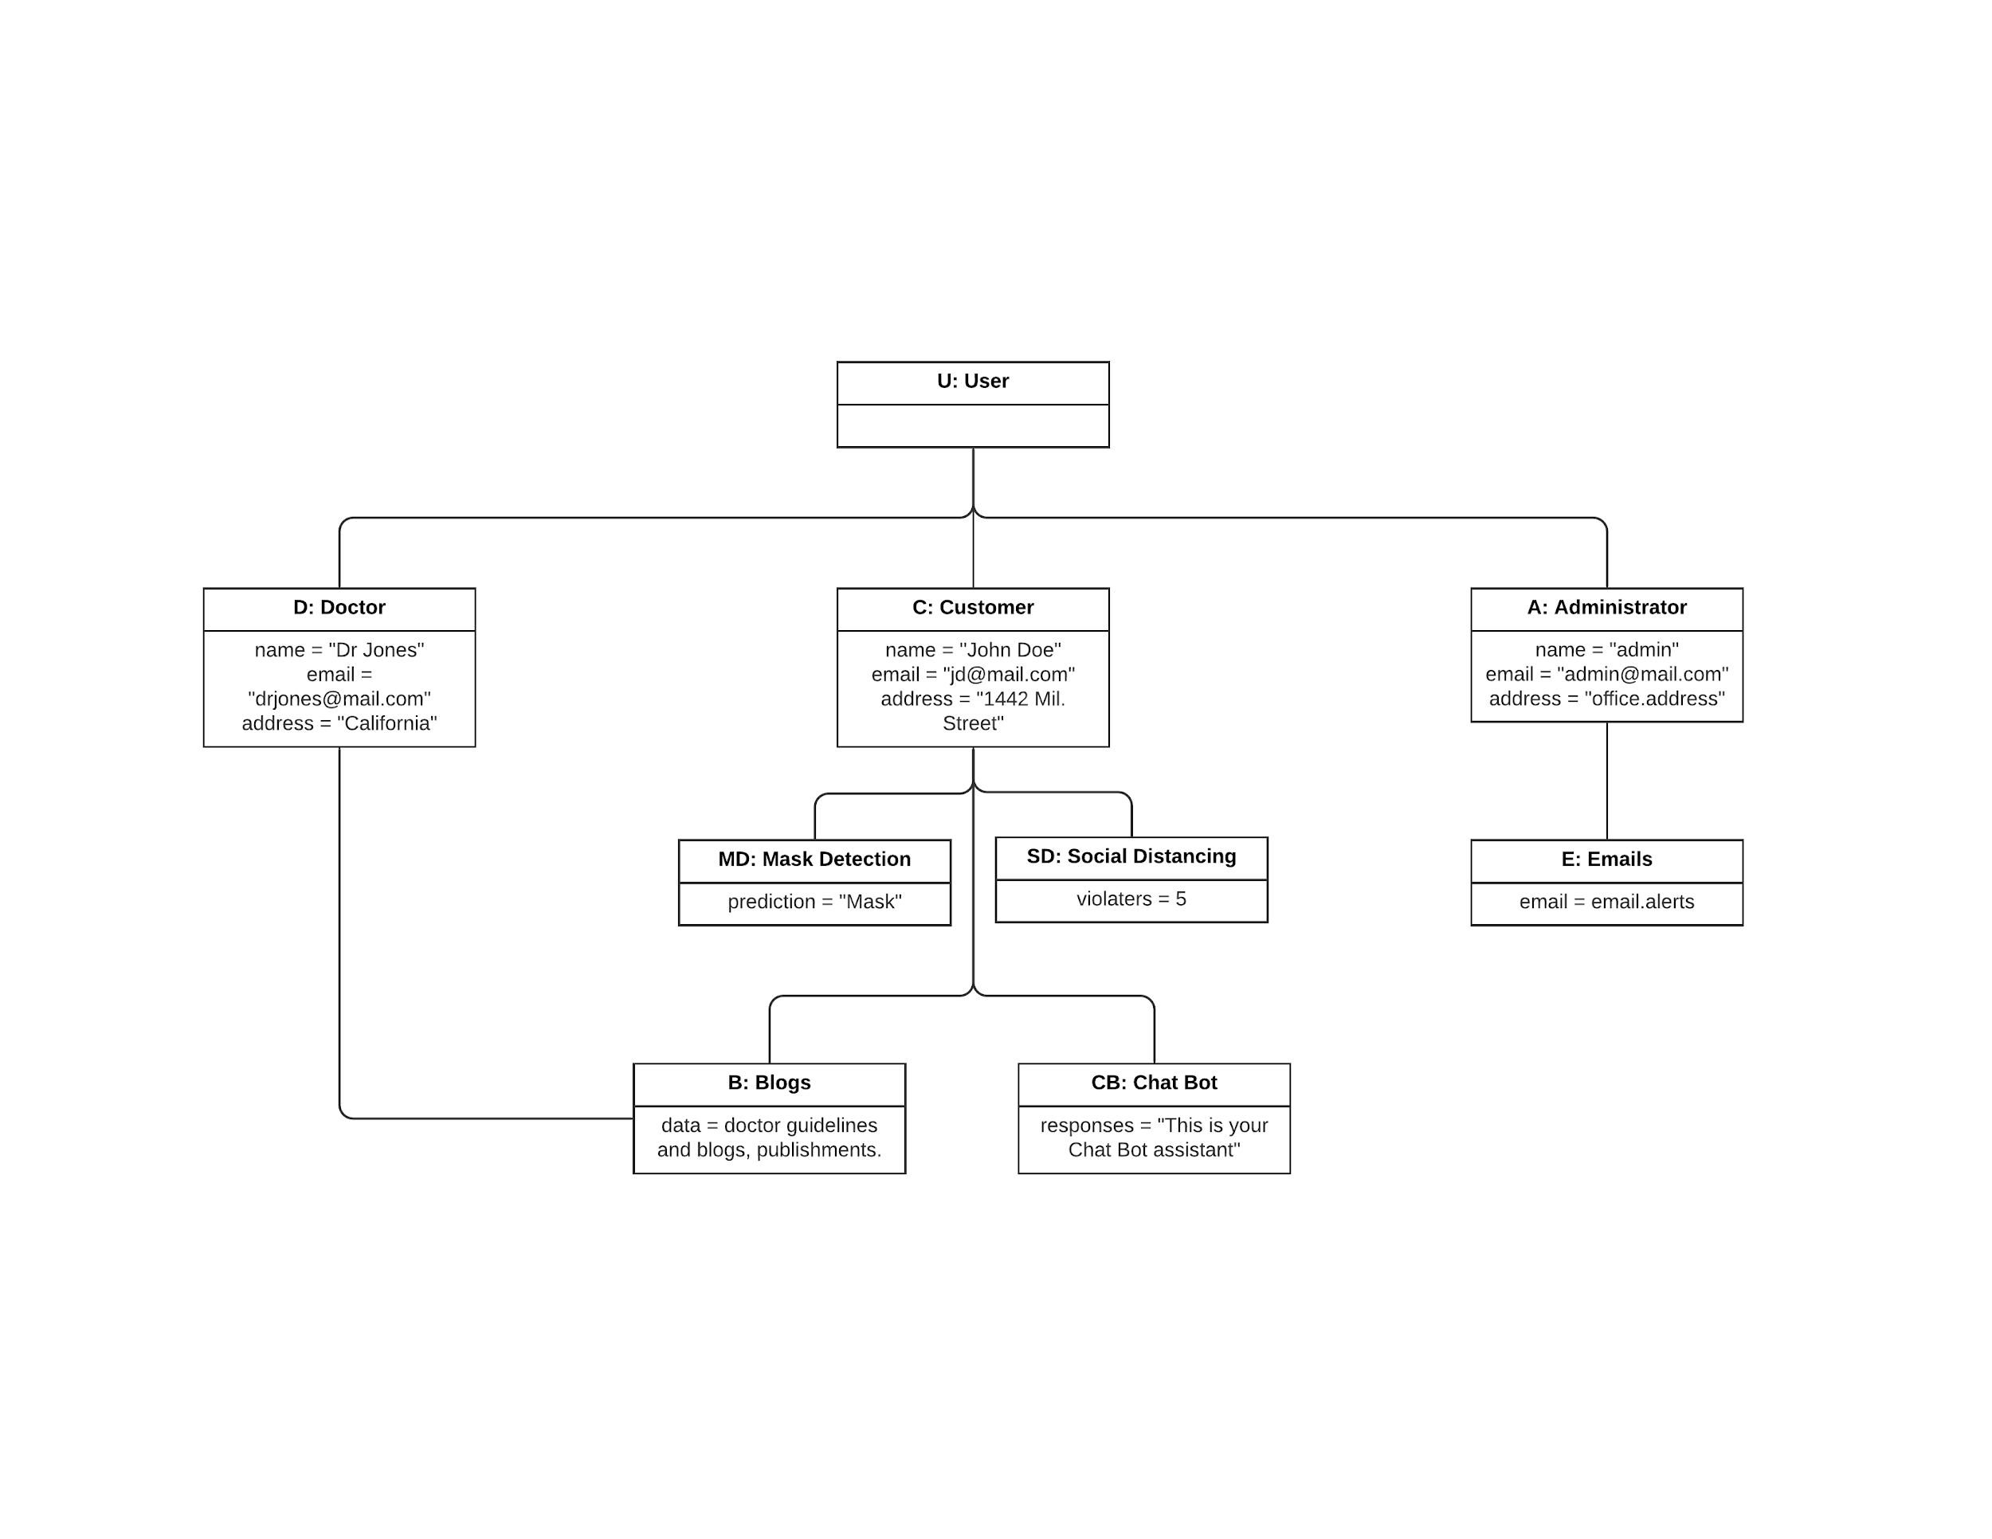

1. UML Component Diagram

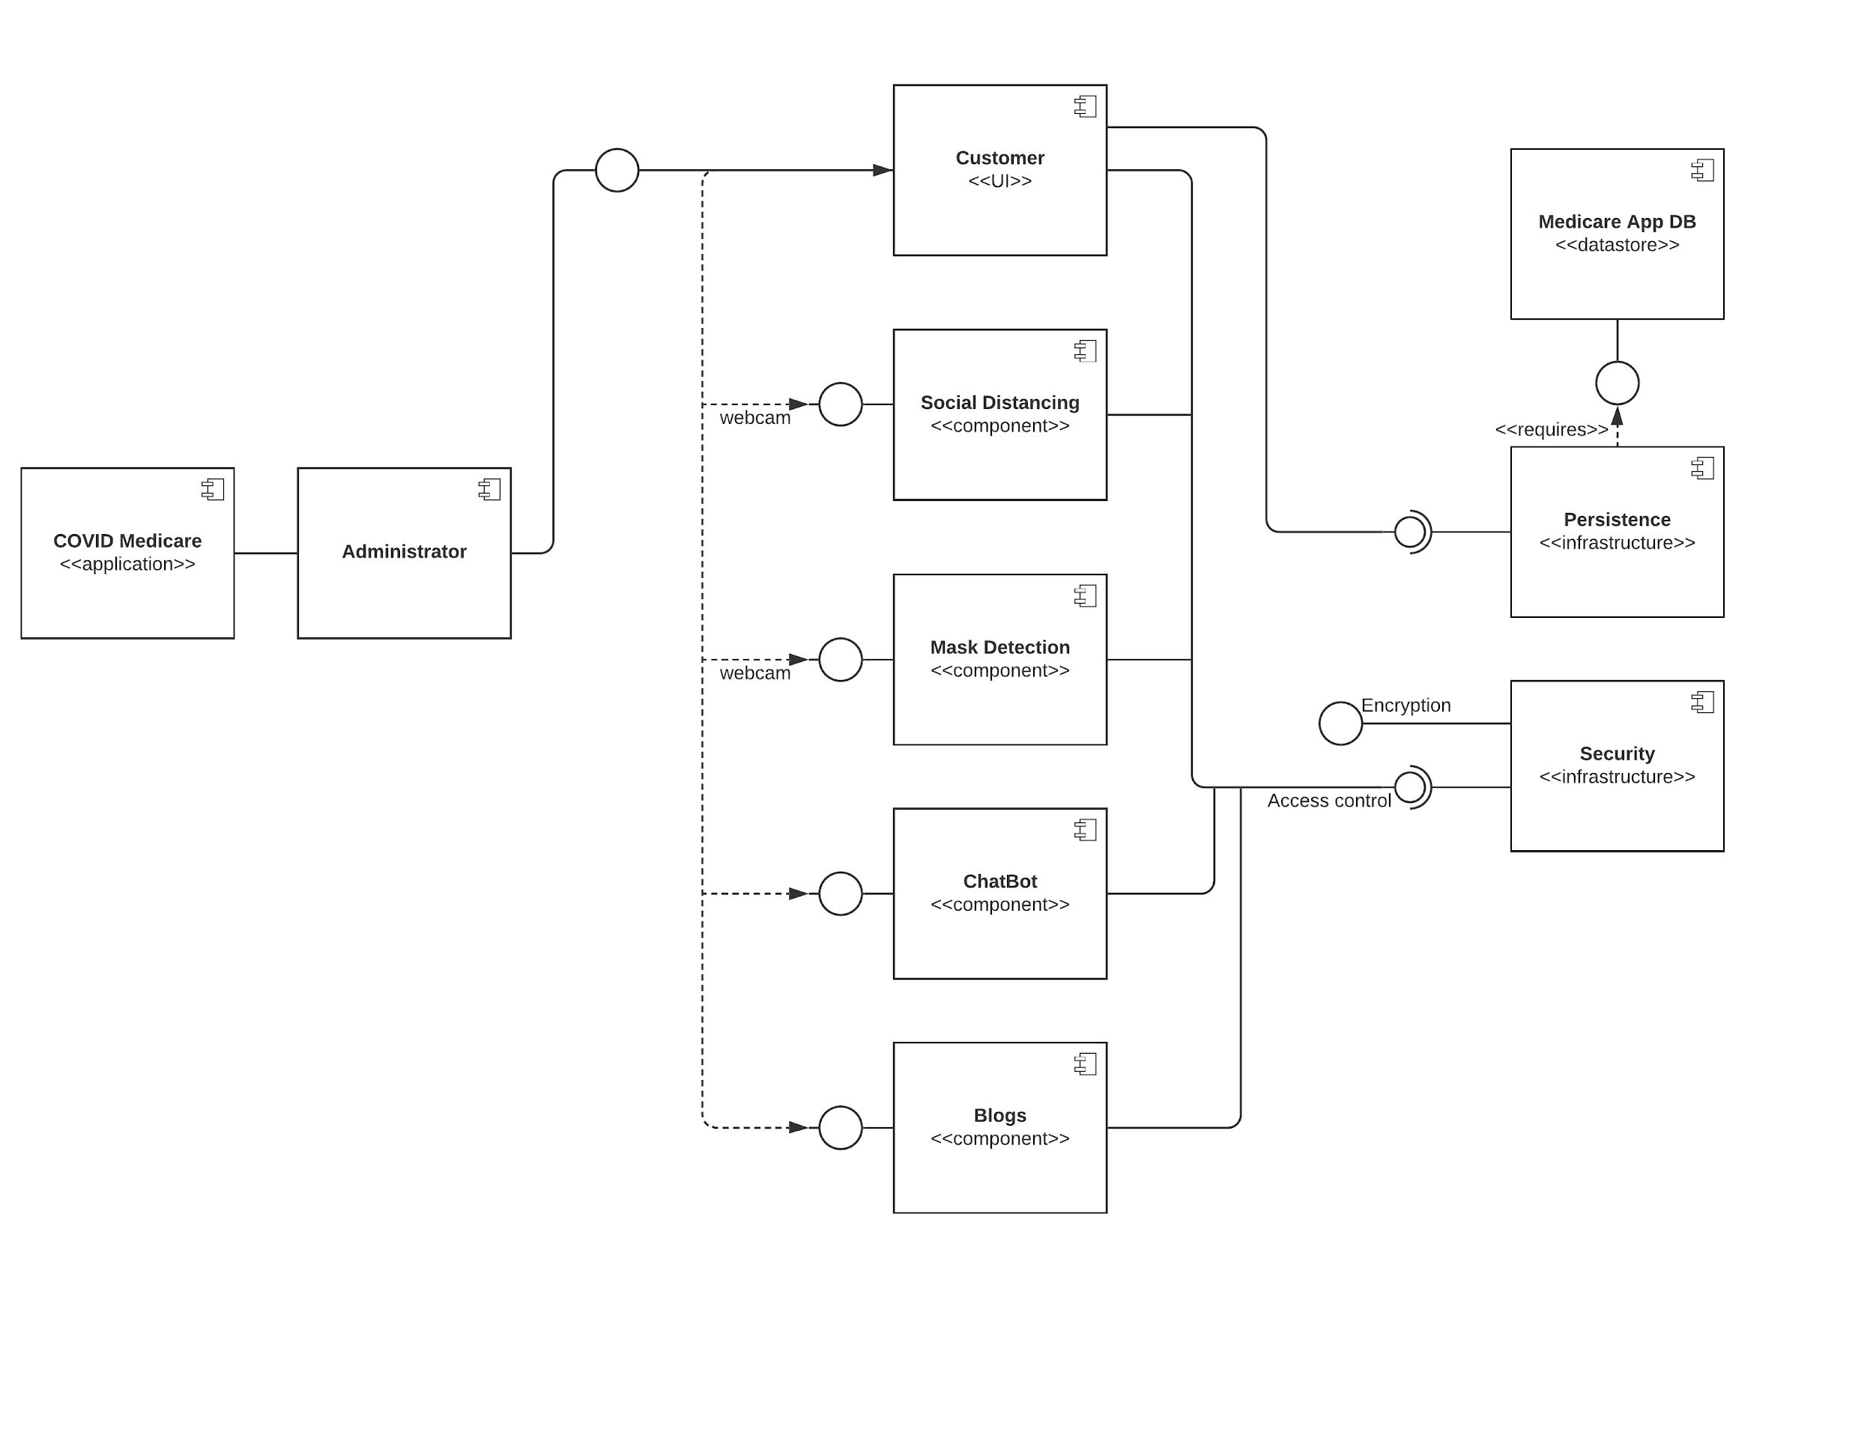

1. UML Deployment Diagram

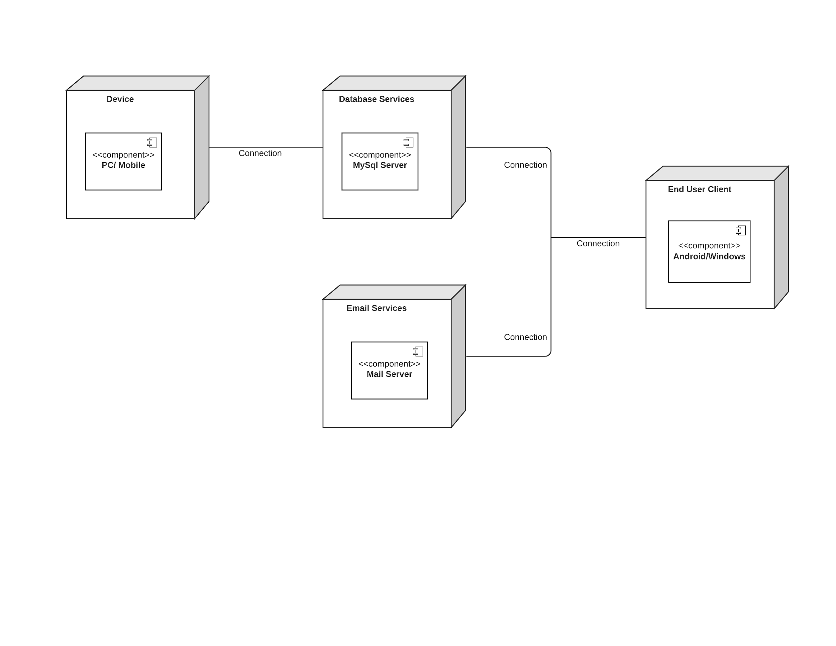

1. UML Use Case Diagram

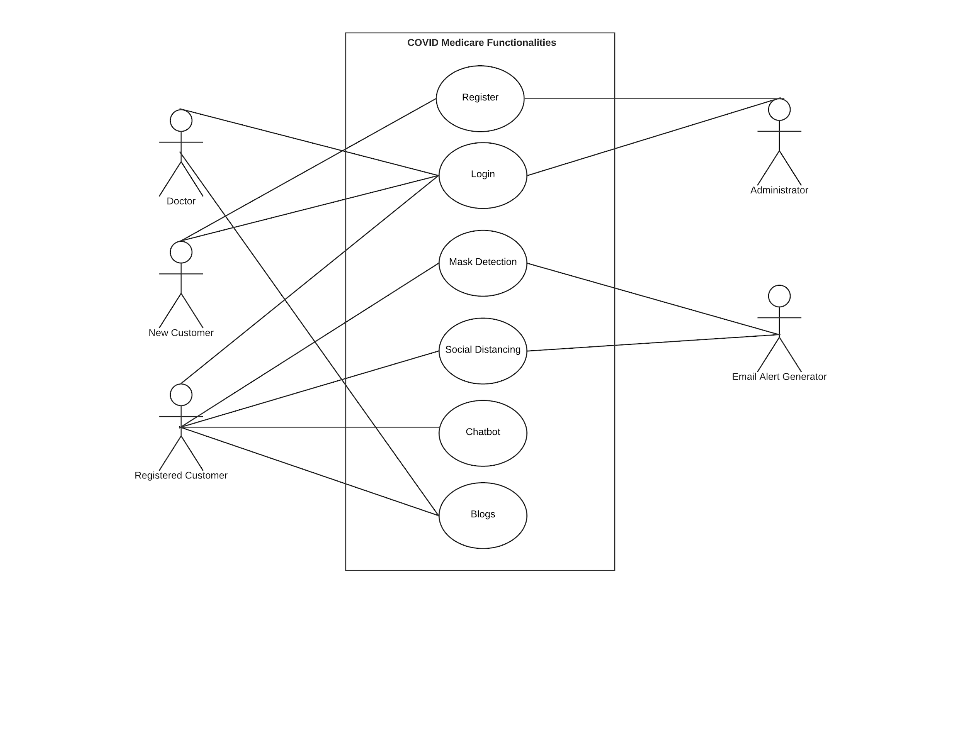

1. UML Sequence Diagram

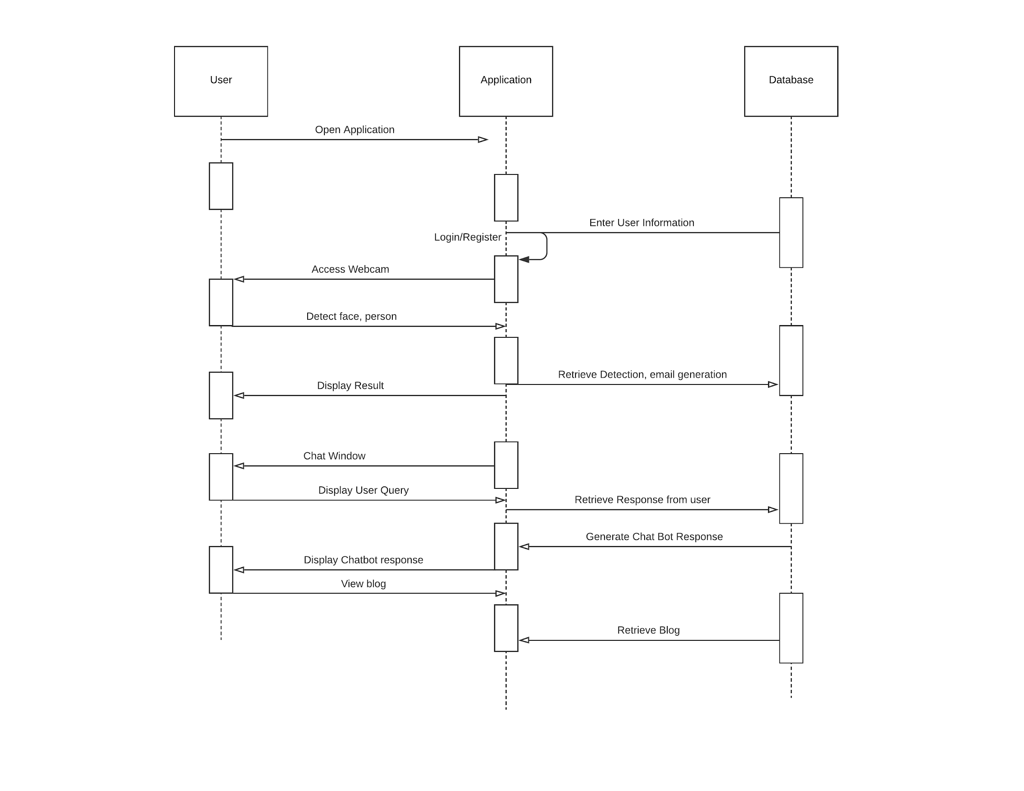

1. UML Collaboration Diagram

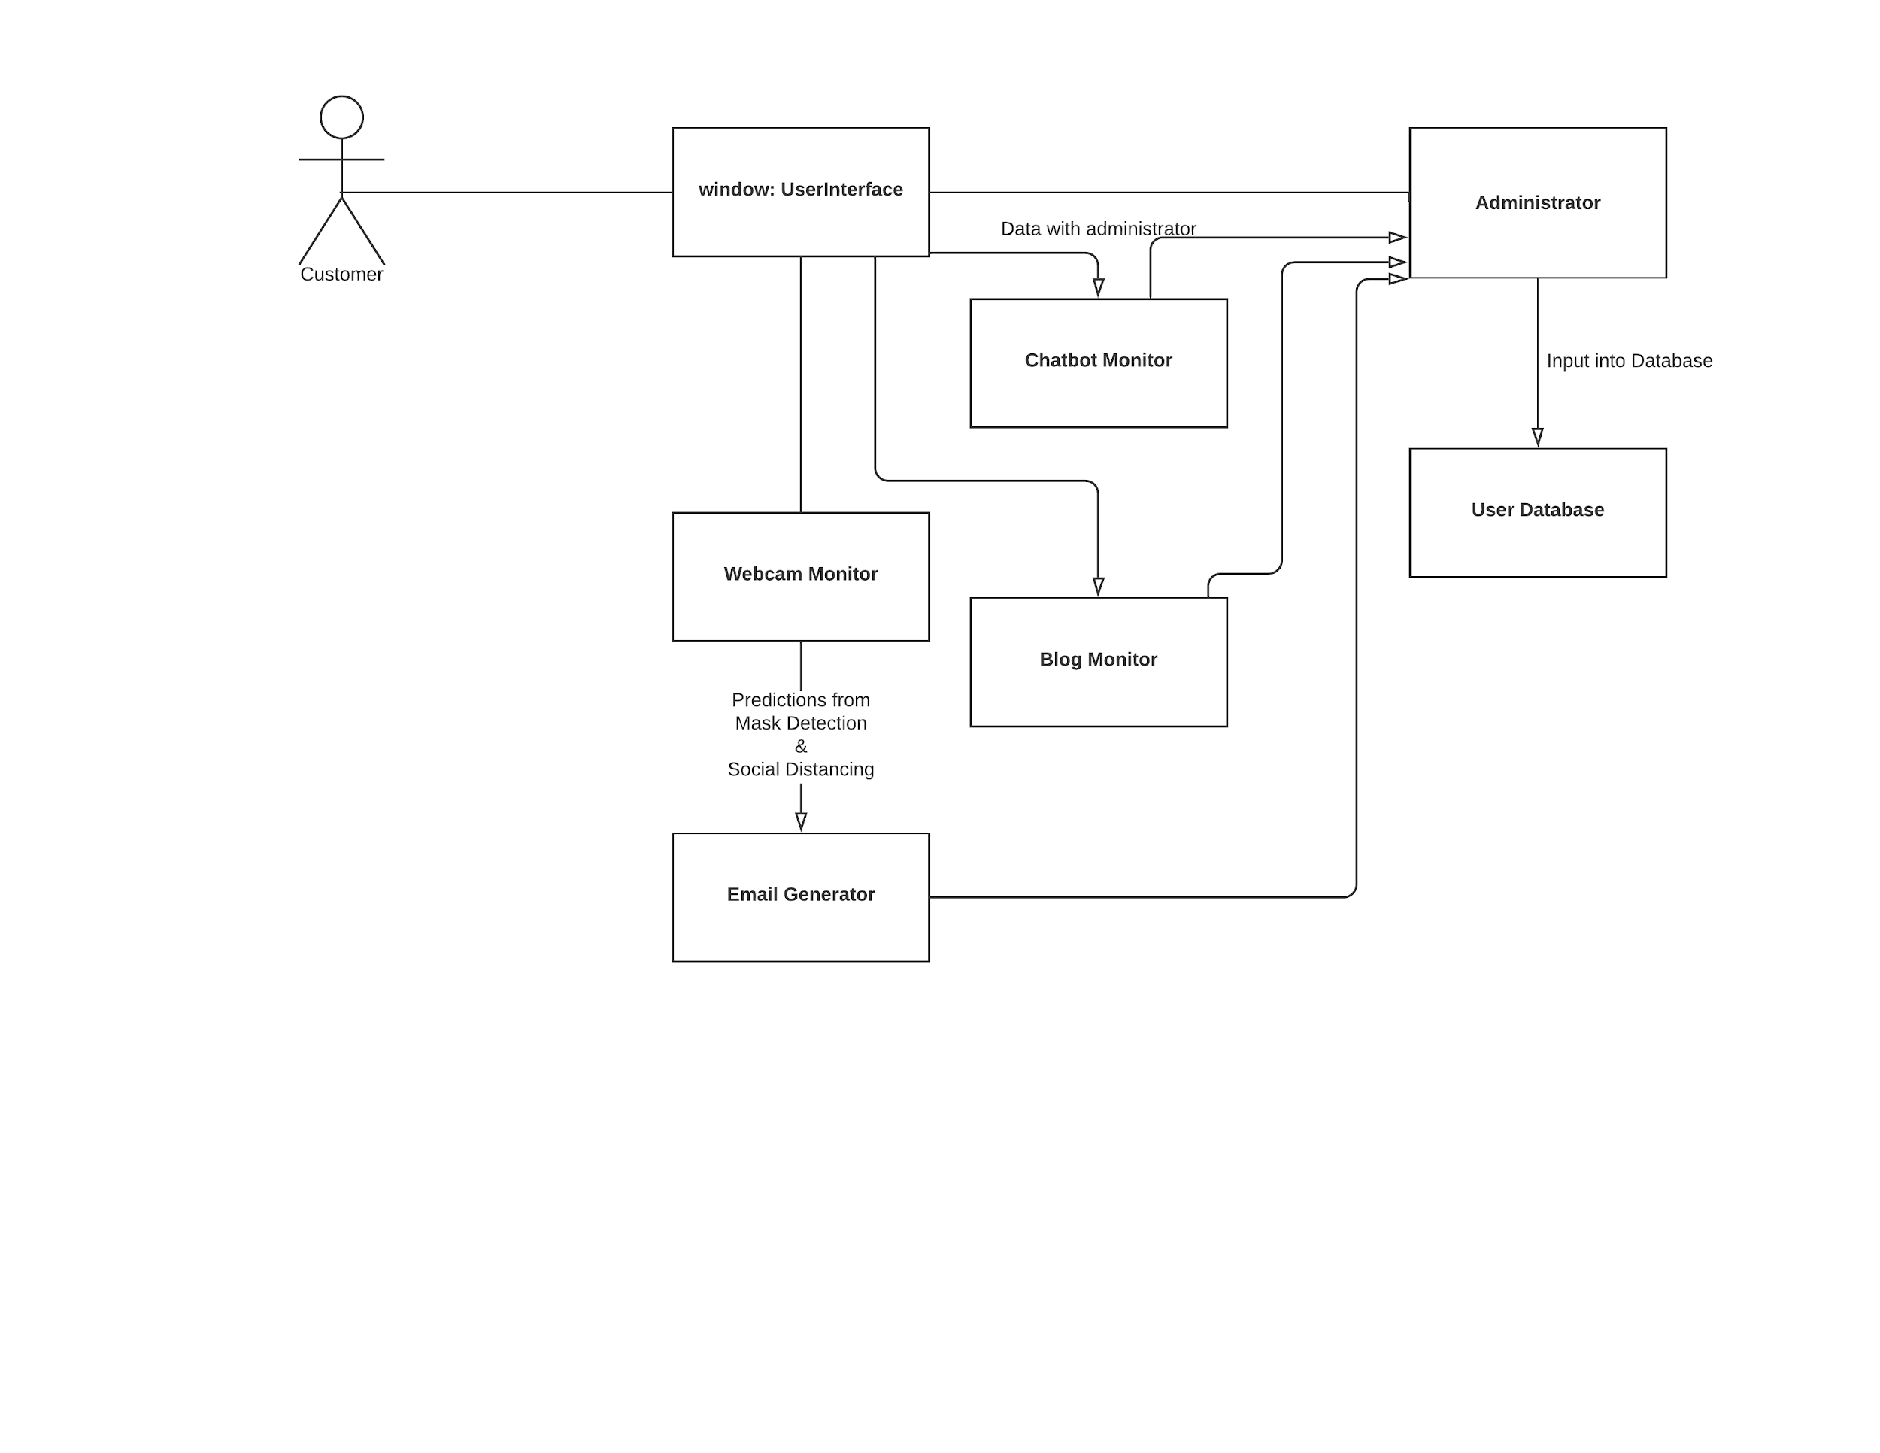

1. UML Statechart Diagram

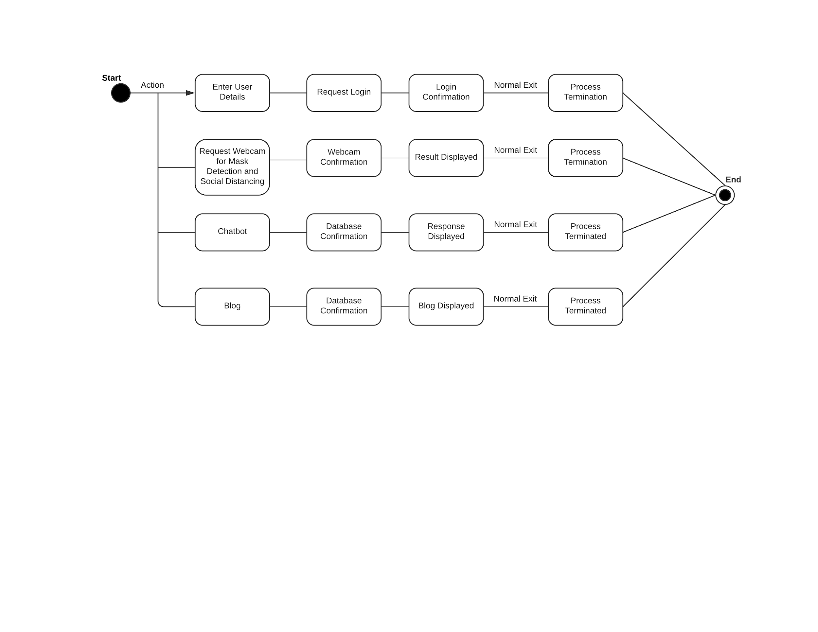

1. UML activity Diagram

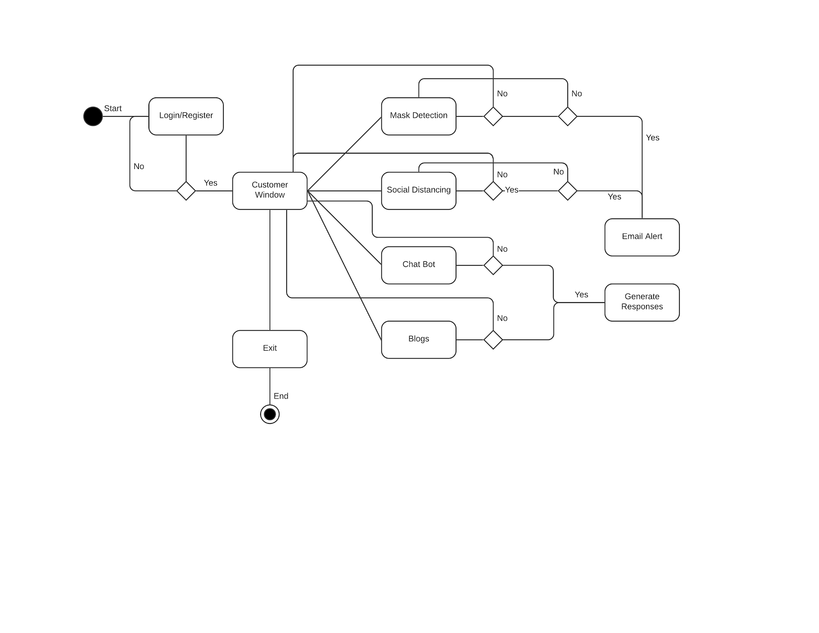

# 

# 

# 

# 

# 

# **Appendix E**: Application Screenshots

1. UI:

Register Screen:

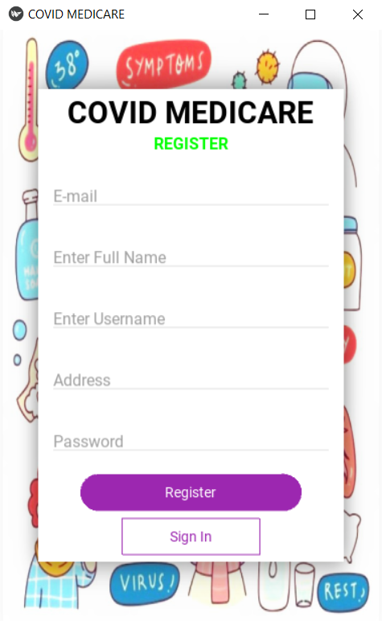

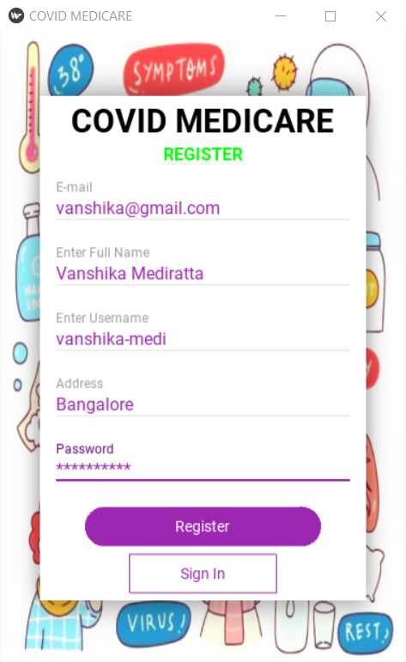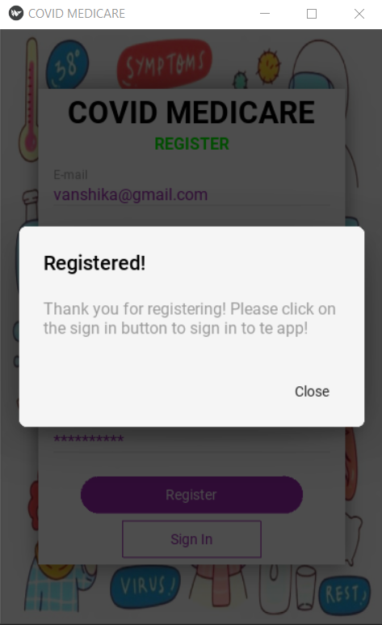

1. Login Screen:

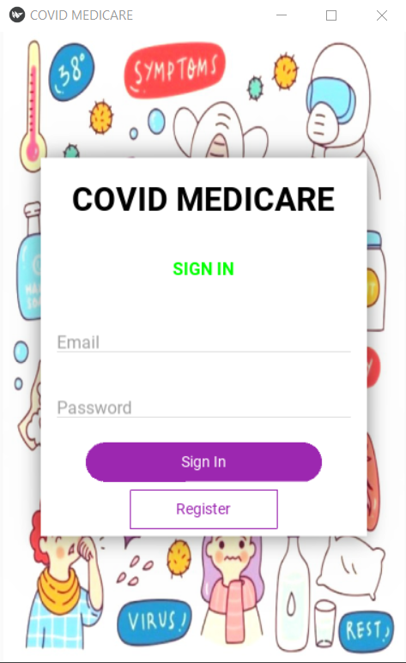

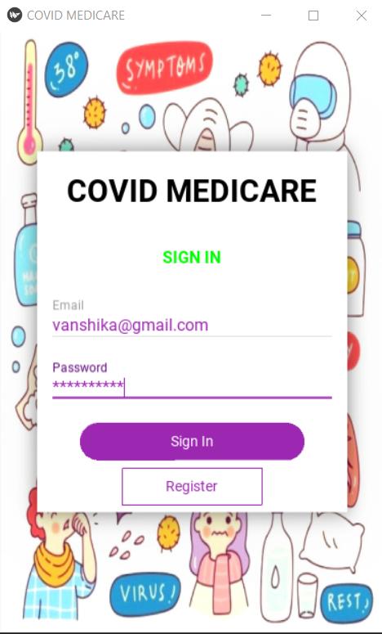

1. Home Screen:

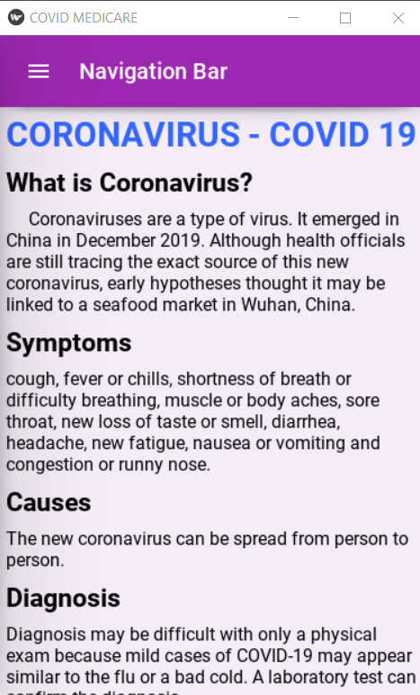

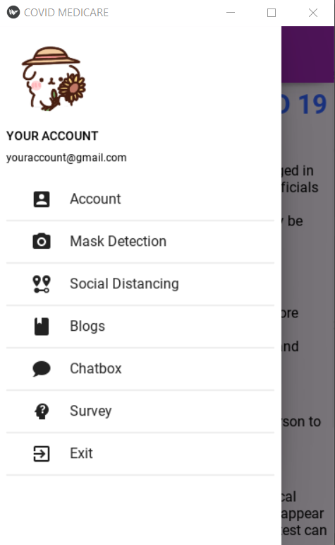

1. Account Screen:

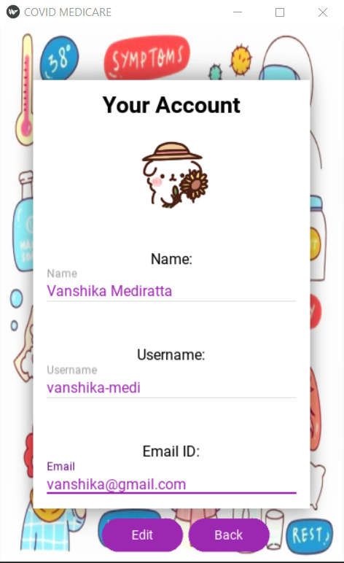

1. Social Distancing Monitor:

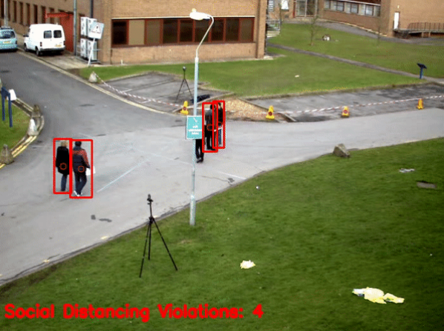

1. Mask Detection

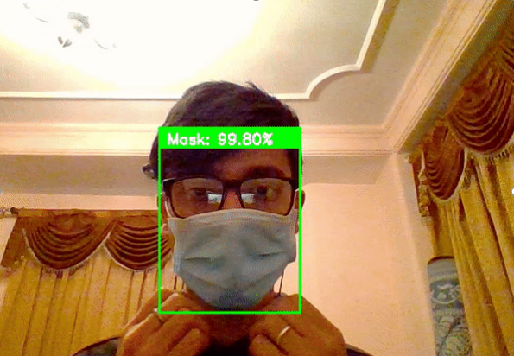

1. Chat Bot

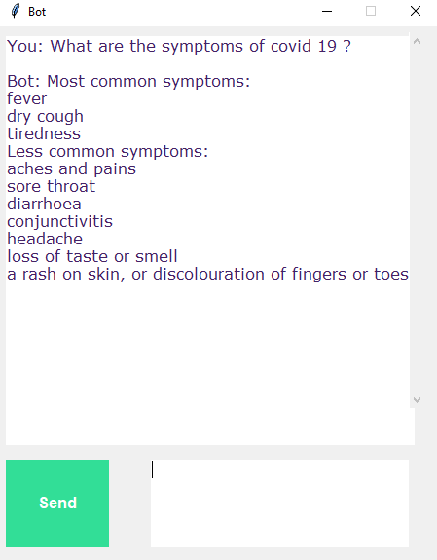

1. Blogs:

